Instruction Sheet
This guide walks you through finding and importing New Literacies Alliance (NLA) lessons into your LMS course. NLA lessons are interactive, self-paced modules designed to teach foundational research and information literacy skills.

How to import from the IMSCC file to Blackboard
Blackboard provides instructions on importing from a file. https://help.blackboard.com/Learn/Instructor/Ultra/Course_Content/Reuse_Content/Import_Course_Packages

How to import from the IMSCC file to Brightspace D2L
The D2L Brightspace Community has documentation on importing course components. https://community.d2l.com/brightspace/kb/articles/16771-import-export-or-copy-course-components

How to import from the IMSCC file to Canvas
Canvas guides have good instructions on importing a course package. The IMSCC file is a course package. https://community.canvaslms.com/t5/Instructor-Guide/How-do-I-import-a-Canvas-course-export-package/ta-p/795

How to Locate and Import NLA Lessons from Canvas Commons

Part 1 – Access Canvas Commons
1. Log in to Canvas
- Go to your institution’s Canvas site and log in with your faculty or staff credentials.
2. Open Canvas Commons
- From the Global Navigation menu on the left, click Commons.
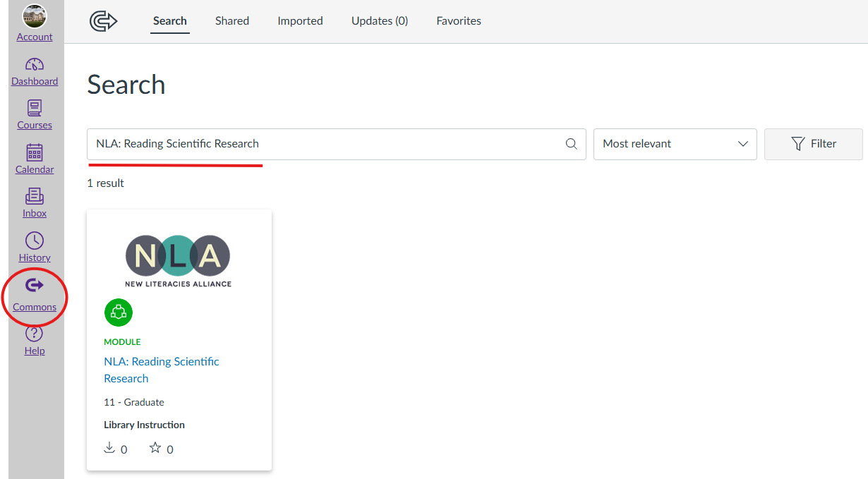

Part 2 – Search for NLA Lessons
1. Use the Search Bar
- In the Commons search box, type the lesson name. Example:
NLA: Access Matters
2. If Too Many Results, Try Filters
- Shared With: Select 'All of Canvas Commons' (unless restricted by your institution).
- Type: Choose 'Modules'.
- Filter by 'Latest' to find the most recent uploads.
3. Identify Official NLA Content
- Look for titles beginning with 'NLA'.
- The NLA logo is on the module.

Part 3 – Preview and Select Lessons
1. Click on a Lesson Title to open its Commons description.
2. Read the Description to verify that the content matches your instructional goals.

Part 4 – Import into Your Canvas Course
1. Click the “Import/Download” Button on the lesson’s Commons page.
2. Select Your Course(s) from the list that appears.
- You can choose multiple courses if needed.
3. Click “Import into Course”.
4. Wait for Processing (usually less than a minute for modules).

Part 5 – Locate and Customize in Your Course
1. Open the Course where you imported the lesson.
2. Go to Modules (or the area where the content was imported).
3. Review the Lesson:
- Update instructions to match your class activities.
- Add quizzes, discussions, or supplemental resources.

Tips & Best Practices
- Link from Assignments – Connect the NLA lesson to a graded assignment so students have a clear reason to complete it.

